**Hardware Components in Computing Systems: An Overview**

**Abstract**

* This document provides a concise overview of key hardware components in modern computing systems, including the Central Processing Unit (CPU), Random Access Memory (RAM), Read-Only Memory (ROM), Hard Disk Drives (HDDs), Solid State Drives (SSDs), and the Motherboard. Function, key characteristics, and their impact on system performance are discussed. This document adheres to a 3-4 page limit, including placeholders for relevant images.

**1. Introduction**

* Modern computing systems are complex assemblies of hardware and software that work together. A fundamental understanding of these components is essential for students of computer science, engineering, and related fields. This document offers an overview of key hardware components, their roles, and their contributions to system functionality. This aims to provide a foundation for understanding computer architecture.

**2. The Central Processing Unit (CPU): The Execution Engine**

* The Central Processing Unit (CPU), or processor, is the core computational unit. Its function is to fetch, decode, and execute instructions, performing arithmetic, logical, and control operations as directed by software. The CPU's capabilities are crucial for determining the overall speed and responsiveness of a computer.

**2.1 Functionality: The CPU operates cyclically, performing the following steps:**

* Fetch: The CPU retrieves the next instruction from system memory (RAM).
* Decode: The instruction is interpreted to determine the specific operation to be performed.
* Execute: The CPU performs the operation using its Arithmetic Logic Unit (ALU). This may involve calculations, data manipulation, or control flow changes.
* Store: The result of the operation is written back to system memory or stored in an internal register for later use.

**2.2 Key Characteristics:**

* Clock Speed (GHz): Indicates the rate at which the CPU executes instructions, measured in gigahertz (GHz). A higher clock speed allows the CPU to complete more cycles per second, generally leading to improved performance.
* Core Count: Modern CPUs often incorporate multiple cores, which are independent processing units within a single physical chip. This allows the CPU to execute multiple instructions simultaneously, improving performance in multi-threaded applications.
* Cache Memory: The CPU utilizes cache memory, a small, fast form of memory, to store frequently accessed data and instructions. This reduces the latency associated with accessing main system memory, thereby speeding up processing. Multiple levels of cache exist (L1, L2, L3), each with varying sizes and speeds. L1 is the fastest and smallest, while L3 is the slowest and largest.
* Instruction Set Architecture (ISA): Defines the set of instructions that the CPU can execute. Common ISAs include x86 (found in most desktop and laptop computers) and ARM (prevalent in mobile devices and embedded systems). The ISA dictates the types of operations the CPU can perform.
* Thermal Design Power (TDP): Specifies the maximum amount of heat that the CPU is expected to generate under typical operating conditions. This value is crucial for selecting an appropriate cooling solution to prevent overheating.

**2.3 Significance:** The CPU significantly impacts system performance. Its speed, core count, cache size, and architectural efficiency are all critical factors that determine how quickly the system can execute tasks.

**CPU Die**

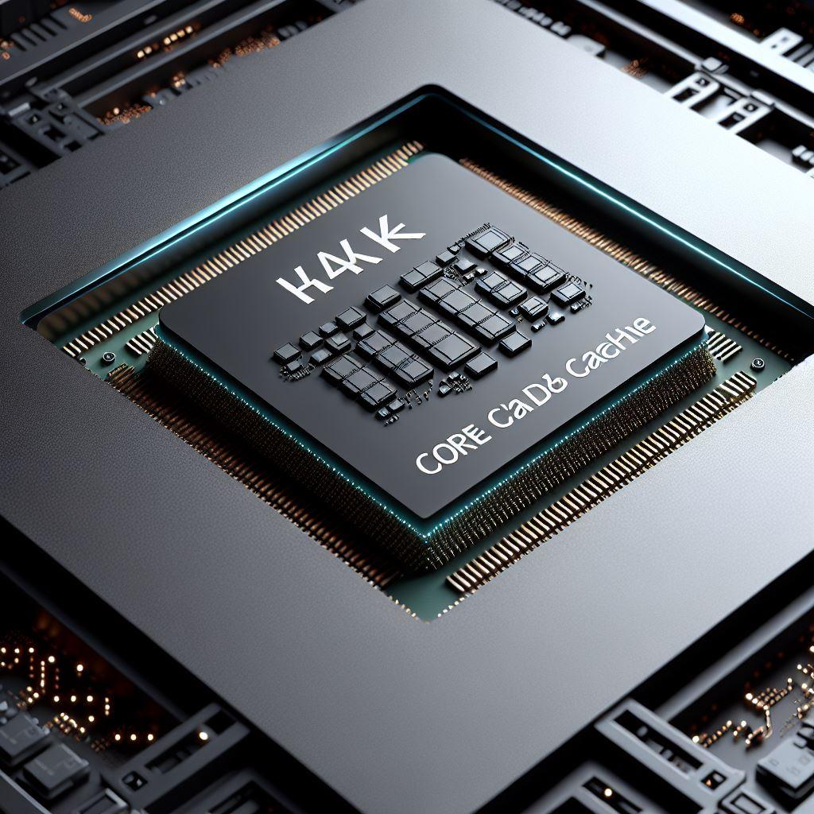

**CPU Package**

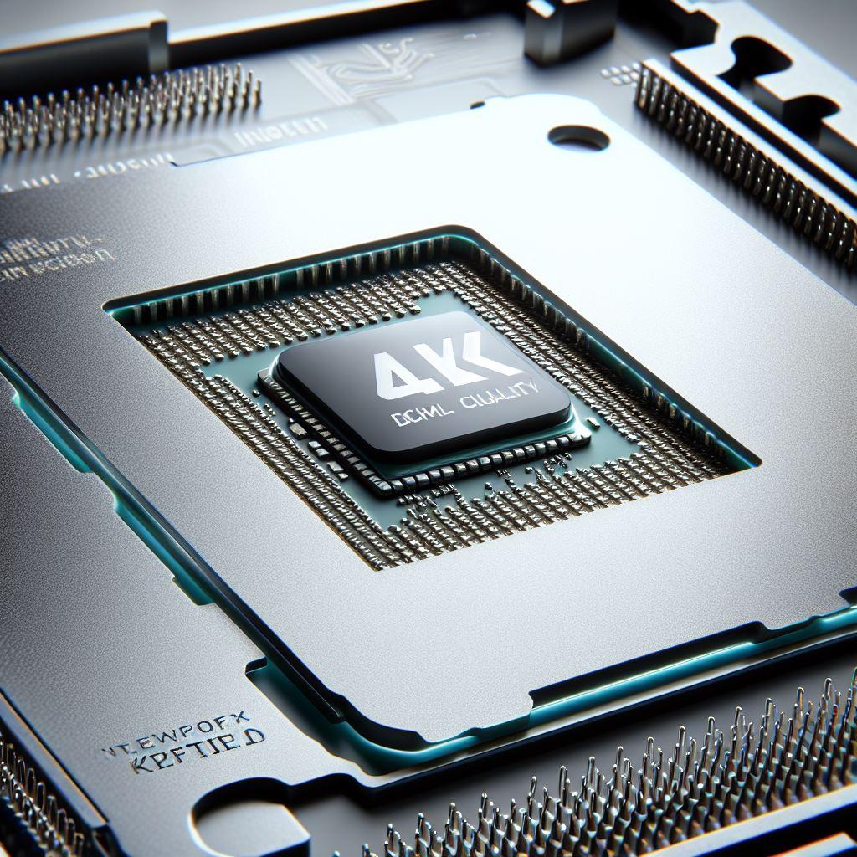

**3. Memory: RAM and ROM**

* Memory provides temporary or permanent storage for data and instructions.

**3.1 RAM (Random Access Memory):**

* Volatile Memory: Data is lost when the power is turned off. RAM is used for temporary storage of data currently being used by the CPU.
* Fast Access: Provides quick read/write access to any location in memory, allowing the CPU to rapidly retrieve and store data.
* Used For: Running programs and storing data currently in use. The more RAM a system has, the more programs it can run simultaneously, and the larger the datasets it can handle, without experiencing performance slowdowns.

**Key Characteristics:**

* **Capacity (GB):** The amount of data that can be stored in the RAM, typically measured in gigabytes (GB).
* **Speed (MHz):** The data transfer rate of the RAM, measured in megahertz (MHz). Faster RAM allows for faster data transfer to and from the CPU.
* **Type (DDR4, DDR5):** Specifies the memory technology used. DDR (Double Data Rate) RAM has evolved through several generations, with DDR5 being the latest, offering increased speed and efficiency.

**3.2 ROM (Read-Only Memory):**

* Non-Volatile Memory: Data is retained even when the power is turned off.
* Slower Access: Primarily read-only, data is written during manufacturing or during specific updates (flashing).
* Used For: Storing firmware, such as the BIOS (Basic Input/Output System) or UEFI (Unified Extensible Firmware Interface), which is essential for booting the computer and initializing hardware components.
* Key Characteristics: Pre-programmed with essential system instructions. Firmware updates are sometimes possible, allowing for bug fixes and compatibility improvements.

**RAM Module**

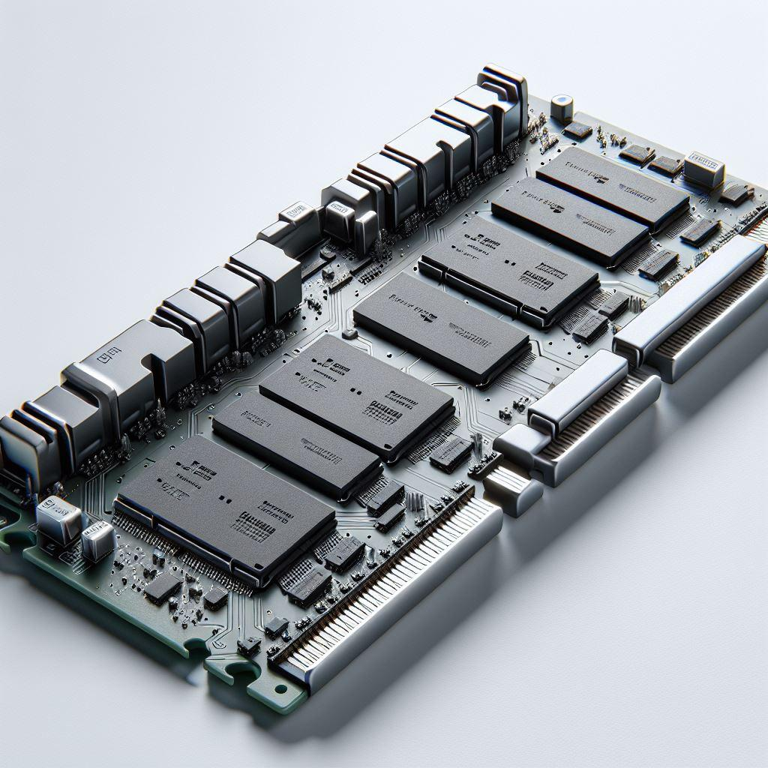

**ROM Chip on Motherboard**

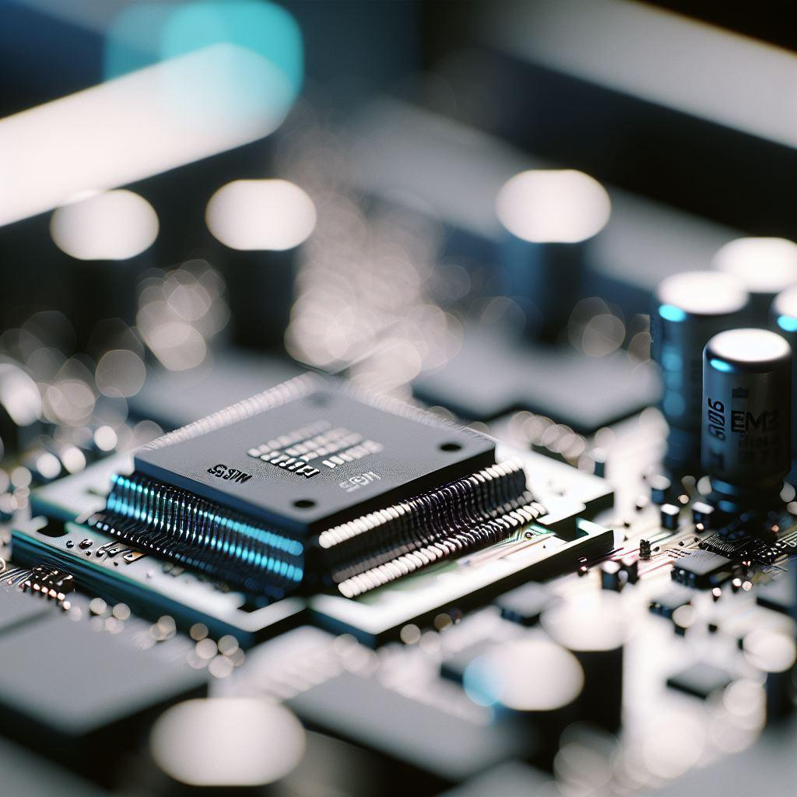

**4. Storage Devices: HDD and SSD**

* Storage devices provide long-term data retention.

**4.1 HDD (Hard Disk Drive):**

* Mechanical Storage: Uses spinning platters coated with magnetic material and read/write heads to access data.
* Non-Volatile Memory: Data is retained even when power is off.
* Higher Capacity, Lower Cost: Generally offers more storage capacity at a lower cost per gigabyte compared to SSDs. This makes them suitable for storing large amounts of data, such as media files and backups.
* Slower Access Times: Significantly slower read and write speeds compared to SSDs due to the mechanical nature of the drive.

**Key Characteristics:**

* Capacity (TB): The amount of data that can be stored, typically measured in terabytes (TB).
* RPM (Revolutions Per Minute): Indicates how fast the platters spin, affecting access speed.
* Interface (SATA): Defines the connection between the drive and the motherboard.
* 4.2 SSD (Solid State Drive):
* Electronic Storage: Uses flash memory chips to store data, with no moving parts.
* Non-Volatile Memory: Data is retained even when power is off.
* Faster Access Times: Significantly faster read and write speeds compared to HDDs, resulting in faster boot times, application loading, and overall system responsiveness.
* Lower Capacity, Higher Cost: Generally offers less storage capacity at a higher cost per gigabyte compared to HDDs.

**Key Characteristics:**

* Capacity (GB, TB): The amount of data that can be stored, measured in gigabytes or terabytes.
* Interface (SATA, NVMe): Defines the connection between the drive and the motherboard. NVMe (Non-Volatile Memory Express) offers much faster speeds than SATA.
* Form Factor (2.5 inch, M.2): Physical size and shape of the drive. M.2 drives are smaller and connect directly to the motherboard.

**HDD (Internal View or External Drive)**

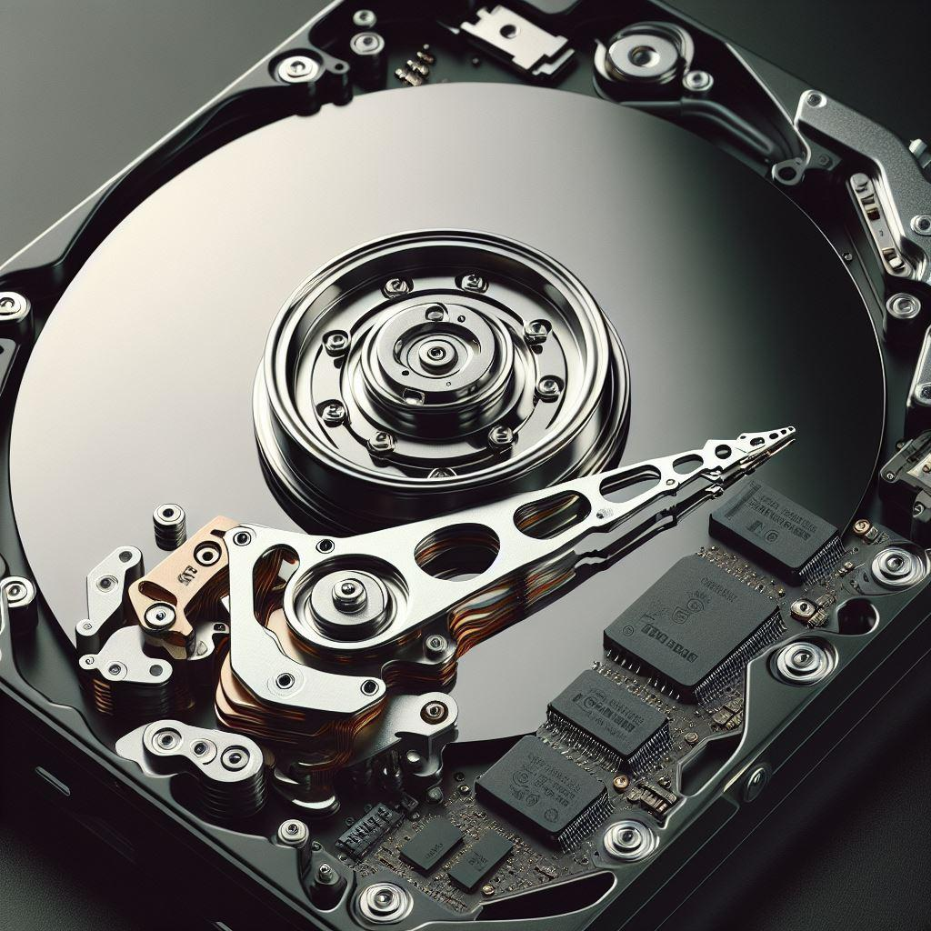

**SSD (SATA or NVMe)**

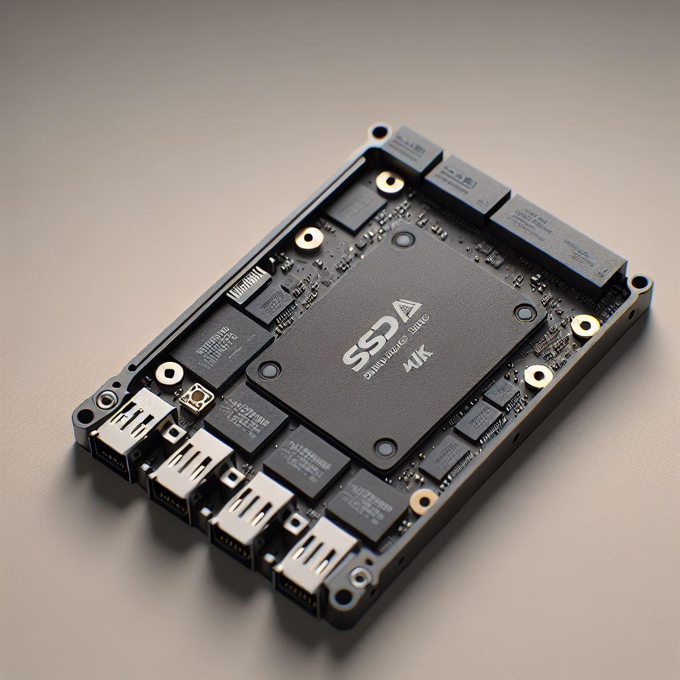

**5. The Motherboard: The Central Hub**

* The motherboard is the main printed circuit board (PCB) within a computer, acting as the central hub that connects all other components.

**Key Characteristics:**

* Form Factor (ATX, Micro-ATX, Mini-ITX): Determines the size and layout of the motherboard, affecting compatibility with computer cases.
* CPU Socket: Specifies the type of CPU that can be installed.
* RAM Slots: Provide slots for installing RAM modules.
* Expansion Slots (PCIe, PCI): Allow for adding expansion cards, such as graphics cards, sound cards, and network cards. PCIe (Peripheral Component Interconnect Express) is the dominant standard.
* Storage Connectors (SATA, M.2): Provide connections for storage devices.
* I/O Ports (USB, Ethernet, Audio): Provide connections for peripherals.
* Chipset: A set of integrated circuits that manages communication between the CPU, memory, and other peripherals. The chipset significantly impacts the features and capabilities of the motherboard.
* Functionality: Power distribution to all components, facilitation of communication between components, and providing expansion capabilities.

**Motherboard (ATX Format with Labeled Ports)**

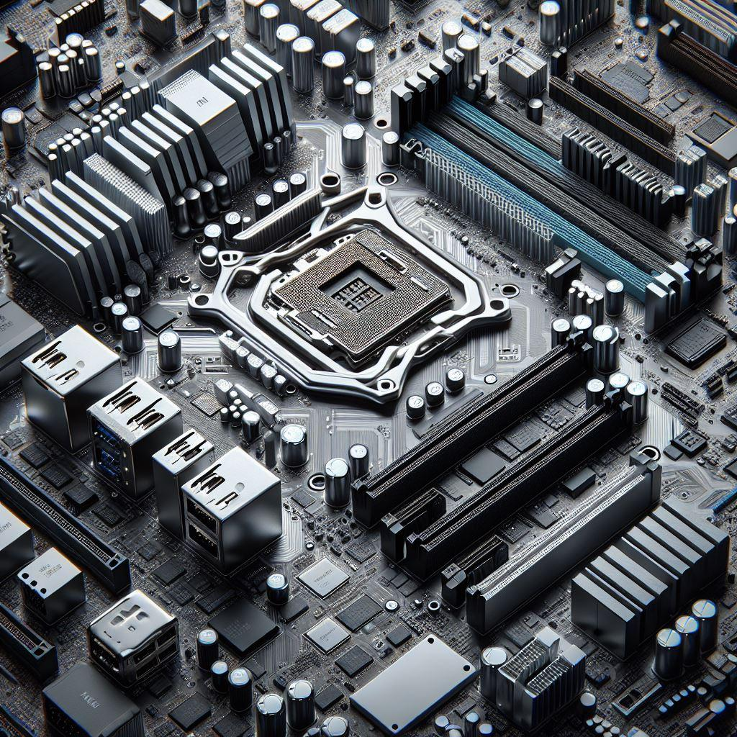

**6. Conclusion**

This document presented an overview of essential hardware components within a computing system. The CPU, RAM, ROM, HDDs, SSDs, and the Motherboard each play critical and distinct roles in enabling computer functionality. A foundational understanding of these components is vital for comprehending how computers operate and for appreciating the interplay between hardware elements that underpins modern computing.

**References**

* Stallings, W. (2019). Computer Organization and Architecture (11th ed.). Pearson.
* Patterson, D.A., & Hennessy, J.L. (2021). Computer Organization and Design
* RISC-V Edition. Morgan Kaufmann.
* Intel. [Website] <https://www.intel.com/>
* AMD. [Website] <https://www.amd.com/>